**Lesson 0**

Qt is a cross-platform application development framework for desktop, embedded and mobile. In this subject it is compiled using C++.

Window Project

helloworld.pro

main.cpp

.h

.cpp

mainWindow.cpp

Qt Class Hierarchy

QString

QPaintDevice

QObject

QLayoutItem

QObject

QObject

QObject

QBoxlayout

QDialog

Directives/Headers

|  |  |  |
| --- | --- | --- |
| Directive | Purpose | Usage |
| QTextStream | Streams | cin(stdin); cout(stdout);  cin >> d; cout << “Hello World”; |
| QApplication | Execute application | a(argc, argv);  a.exec(); |
| QMessageBox | Modal dialog | QMessageBox::StandardButton reply;  reply = QMessageBox::question(0, "Coordinate", "Enter another coordinate?",QMessageBox::Yes|QMessageBox |
| QInputDialog |  | QInputDialog::getText(0,"Input","Please enter stuff”), QLineEdit::Normal, QString(""), &ok); |
| QDebug | Debugging to console | qDebug() << "Hello World"; |
| QString | Strings | QString::number(degrees);  myString.toUpper(); |
| QStringList | String Objects | inputCoordinates.split(" ") |
| QChar | Characters | QChar(0260); |

**Lesson 1**

Windows

Widgets

Layouts

Signals

Slots

**Widgets**

A user interface object that can process input, emit signals and

draw graphics

– A widget can be styled to have a vastly different appearance than

its default

– Most widgets generate signals that can be received by pieces of

your code called slots

**Layouts**

A layout describe how widgets are organized and positioned in a

user interface. The jobs of a QT layout:

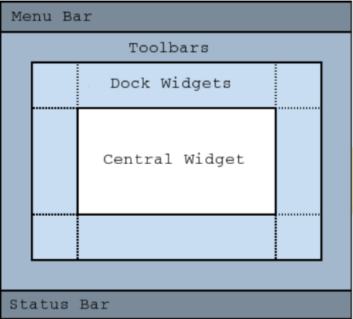- Positioning of widgets in GUI

- Font size, text or other widget changes

- Add or removal of new widgets

- Showing and hiding of existing widgets

Four different layouts are commonly used

– QVBoxLayout

– QHBoxLayout

– QFormLayout

– QGridLayout

QT layouts and widgets share numerous parent/child

relationships

– Widgets can contain other widgets

– Widgets can have layouts

– Layouts can contain widgets

– Layouts can contain other layouts

– There can be a gigantic graph of parent and child relationships in a GUI

**Slots & Signals**

In QT, all widgets are capable of firing events and receiving

events

– Signals are used to notify (emit) widgets of an event

– Slots are used to receive (listen for) widget events

– connect is used to tie together a signal & a slot

– Signals & slots can have M-to-N connections

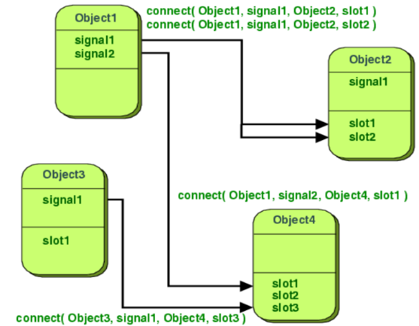

QAction

commands can be invoked via menus, toolbar buttons, and keyboard shortcuts. Each of these commands is represented as an action with QAction.

Once a QAction has been created it should be added to the relevant menu and toolbar, then connected to the slot which will perform the action.

QActionGroup can be used to group these together for context awareness. For example , if you have a Left Align action, a Right Align action, a Justify action, and a Center action, only one of these actions should be active at any one time.

Example: ASS3 Different buttons on a GUI to perform the same action

MyMainWindow::MyMainWindow() : textEdit(new QTextEdit(this)) {

QActionGroup * fileGroup = new QActionGroup(this);

fileGroup->addAction(new QAction(QIcon("/icons/o.png"), "&Open", this));

fileGroup->addAction(new QAction(QIcon("/icons/s.png"), "&Save", this));

fileGroup->addAction(new QAction(QIcon("C/icons/x.png"), "E&xit", this));

}

**Lesson 3**

QT Classes

**Parameterized Constructor**

A default constructor does not have any parameter, but if you need, a constructor can have parameters. This helps you to assign initial value to an object at the time of its creation

**The Class Constructor**

A class constructor is a special member function of a class that is executed whenever we create new objects of that class.

GPSCoord::GPSCoord():

latitude(new Coordinate(0, 0, 0, 'N')),

longitude(new Coordinate(0, 0, 0, 'E')) {

}

**The Class Destructor**

A destructor is a special member function of a class that is executed whenever an object of it's class goes out of scope or whenever the delete expression is applied to a pointer to the object of that class.

GPSCoord::~GPSCoord(){

delete latitude;

delete longitude;

}

**Copy constructor**

The copy constructor is a constructor which creates an object by initializing it with an object of the same class, which has been created previously. The copy constructor is used to −

•Initialize one object from another of the same type.

•Copy an object to pass it as an argument to a function.

•Copy an object to return it from a function.

GPSCoord & GPSCoord::operator=(const GPSCoord & g) {

*latitude = *g.latitude;

*longitude = *g.longitude;

return *this;

}

Difference between copy constructor and assignment

A copy constructor is used to initialize a newly declared variable from an existing variable. This makes a deep copy like assignment, but it is somewhat simpler:

1.There is no need to test to see if it is being initialized from itself.

2.There is no need to clean up (eg, delete) an existing value (there is none).

3.A reference to itself is not returned.

**Static members**

We can define class members static using static keyword. When we declare a member of a class as static it means no matter how many objects of the class are created, there is only one copy of the static member.

A static member is shared by all objects of the class. All static data is initialized to zero when the first object is created, if no other initialization is present. We can't put it in the class definition but it can be initialized outside the class as done in the following example by redeclaring the static variable, using the scope resolution operator :: to identify which class it belongs to.

**References**

A reference variable is an alias, that is, another name for an already existing variable. Once a reference is initialized with a variable, either the variable name or the reference name may be used to refer to the variable.

References vs Pointers

References are often confused with pointers but three major differences between references and pointers are −

•You cannot have NULL references. You must always be able to assume that a reference is connected to a legitimate piece of storage.

•Once a reference is initialized to an object, it cannot be changed to refer to another object. Pointers can be pointed to another object at any time.

•A reference must be initialized when it is created. Pointers can be initialized at any time.

**Lesson 4**

Access Control & Inheritance

The public Members

A public member is accessible from anywhere outside the class but within a program.

The protected Members

A protected member variable or function is very similar to a private member but it provided one additional benefit that they can be accessed in child classes which are called derived classes.

The private Members

A private member variable or function cannot be accessed, or even viewed from outside the class. Only the class and friend functions can access private members.

|  |  |  |  |
| --- | --- | --- | --- |
| Access | Public | Protected | Private |
| Same Class | Yes | Yes | Yes |
| Derived Classes | Yes | Yes | No |
| Outside Classes | Yes | No | No |

Type of Inheritance

We hardly use protected or private inheritance, but public inheritance is commonly used. While using different type of inheritance, following rules are applied:

**Public Inheritance**

When deriving a class from a public base class, public members of the base class become public members of the derived class and protected members of the base class become protected members of the derived class. A base class's private members are never accessible directly from a derived class, but can be accessed through calls to the public and protected members of the base class.

**Protected Inheritance**

When deriving from a protected base class, public and protected members of the base class become protected members of the derived class.

**Private Inheritance**

When deriving from a private base class, public and protected members of the base class become private members of the derived class.

**Lesson 5**

**Relationships**

**UML Diagrams**

**Multiplicity**

This association relationship indicates that (at least) one of the two related classes make reference to the other. This relationship is usually described as "A has a B"

The UML representation of an association is a line connecting the two associated classes. At each end of the line there is optional notation.

0 No instances (rare)

0..1 No instances, or one instance

1 Exactly one instance

1..1 Exactly one instance

0..* Zero or more instances

* Zero or more instances

1..* One or more instances

**Lesson 6**

OOP

Parent-child hierarchy implemented in QObject

– Initialization with pointer to parent QObject

parent adds new object to list of its children

– Delete parent: automatically deletes all its children (recursively)

– Delete child: automatically removed from parent’s child list

– Some memory management handled by Qt, only delete objects created with new without parent

Widgets

– Parent has additional meaning: child widgets shown within parent’s area

**Containers**

Containers are objects that can contain other objects.

To use a generic container, the declaration should answer the question: “Container of what?” For example:

QList<double> doubleList;

QList<Thing> thingList;

Example: implementation of a container class

class ItemList {

private:

//The list should not be accessible from outside the class

QMap<QString, Item*> list;

bool changed;

public:

ItemList();

void readList(QString fname);

void writeList(QString fname);

bool getChanged() const;

void addItem(const Item & i);

bool removeItem(QString b);

Item * findItem(QString b) const;

QStringList toStringList() const;

~ItemList();

};

**QList<T>**

The most commonly used container class. It stores a list of values of a given type (T) that can be accessed by index.

Internally, the QList is implemented using an array, ensuring that index-based access is very fast.

QStringList inherits from QList<QString>.

Add items to a list:

QList::append() insert at end

QList::prepend() inert at beginning

QList::insert() insert in the middle

**Inheritance**

#indef CHILD_H

#define CHILD_H

#include “parent.h”

// Sub class inheriting from Base Class(Parent)

class Child: public Parent {

public :

int i_c;

};

#endif // CHILD_H

#indef PARENT_H

#define PARENT_H

class Parent {

public :

int id_p;

};

#endif // PARENT_H

#indef CHILDLIST _H

#define CHILDLIST_H

#include “child.h”

// Container class that manages a list of child

class ChildList: public QList<Child*>{

public :

int i_cl;

};

#endif // CHILDLIST _H

#include <QTextStream>

#include <QApplication>

//main function

int main()

{

QApplication a;

a(argc, argv);

cout(stdout);

Child obj1;

// child has all data members and member functions of class parent

obj1.id_c = 7;

obj1.id_p = 91;

cout << "Child id is " << obj1.id_c << endl;

cout << "Parent id is " << obj1.id_p << endl;

a.exec();

}

**Polymorphism**

#indef PARENT_H

#define PARENT_H

class Parent {

public :

int id_p;

//Constructor

Parent(int id);

//Add virtual destructor to make polymorphic

virtual ~Parent();

};

#endif // PARENT_H

#include <QTextStream>

#include <QApplication>

//main function

int main()

{

QApplication a;

a(argc, argv);

cout(stdout);

Parent c;

//Run-time Type Identification (RTTI), cast to a specific type

if(dynamic_cast<Child*>(c)->id_c == “C49”){

cout << “Child ID is ‘C49’\n”;

}

a.exec();

}

#include "journalarticle.h"

//constructor for child class

JournalArticle::JournalArticle(QString _title,

QStringList _authors,

int _year,

QString _refID,

QString _journalName,

int _volume,

int _number):

//constructor for parent class

Reference(_title, _authors, _year, _refID),volume(_volume), number(_number){

}

**Lesson 7**

ViewModels

Model/View is a technology used to separate data from views in widgets that handle data sets. Standard widgets are not designed for separating data from views and this is why Qt has two different types of widgets. Both types of widgets look the same, but they interact with data differently.

Standard View Model

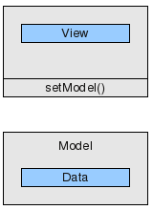

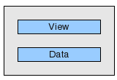

Example: ASS3 A View (Class implemented as a container)

class ItemDialog : public QDialog {

Q_OBJECT

private:

ItemDialog(QWidget * p, QString t, Item * i);

Item * getItem() const;

public:

static Item * changeItem(QWidget * p, Item * i);

static Item * addItem(QWidget * p);

private:

Item * item;

QLineEdit * barcodeLineEdit;

//...

};

Example: ASS3 A Model (Class implemented as a container)

class ItemList {

private:

QMap<QString, Item*> list;

bool changed;

public:

ItemList();

void readList(QString fname);

void writeList(QString fname);

bool getChanged() const;

//...

~ItemList();

};

**Lesson 8**

**Lesson 9**

Lesson 10

Lesson 11

Lesson 12

Lesson 13

Lesson 14